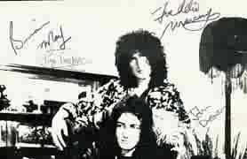  Rare early Queen signatures on a 1973 flyer. This is what the signatures looked like in the first half of 70's. | 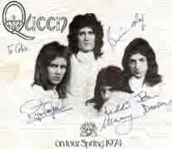  Rare example of early Queen signatures on a Queen II tour flyer (1974).

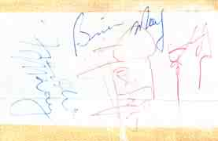  Obtained in Bournemouth, most likely on 30.11.1973 (the signatures are on a ticket to a disco in Bournemouth. | One of the few genuine signed items on eBay :-)

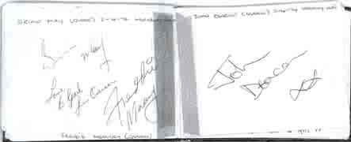
Beautiful signatures obtained in Holiday Inn in Birmingham (2.4.1974).

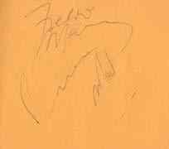  Early signatures of Freddie and Brian, signed on a piece of paper. They may look strange to you but are genuine! | 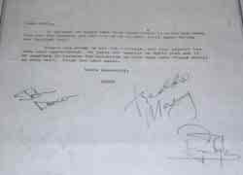  An early letter (April 1974) - once again, these signatures are typical for the 1973-1978 period.

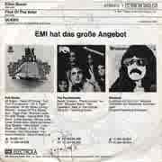  Typical Queen signatures from those days... | 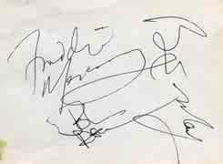  Not very nice signatures but I'm sure they're genuine.

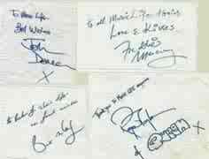  Very rare message from the Queen members to readers of famous Japanese magazine 'Music Life'. Signed either in 1975 or 1976. | 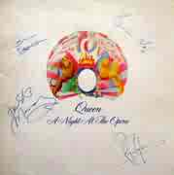  Ugly Freddie's signature? Yes but that's typical for that era. This LP comes from Ratty's personal collection.

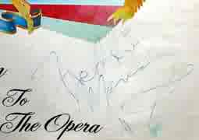  Once again a genuine but ugly Freddie's signature from 1975. | 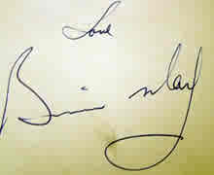  Something from 1975 - most Brian's signatures from that era look exactly like this.

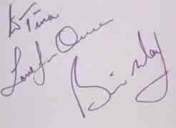  Another typical Brian's signature from mid 70's. | 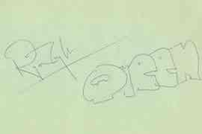  Roger's signature. When he was in good mood, he often added a nice graphic version of the word 'Queen'. Probably from mid 70's.

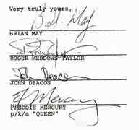  Signatures on official documents were different. Brian often signed as B.H.May while Freddie shortened his first name to just "F". But if you see "FMercury" on an LP, it's almost certainly fake! | 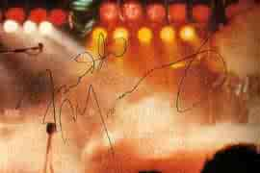  Signed spring 1978 tour programme, signatures obtained by Joe Trovato (lighting director).

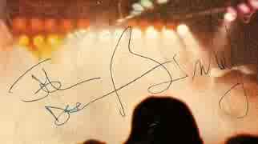
Signed spring 1978 tour programme, signatures obtained by Joe Trovato (lighting director).

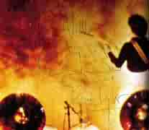  Signed spring 1978 tour programme, signatures obtained by Joe Trovato (lighting director). | 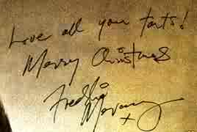  Christmas card from Freddie to his friends, I estimate it's from mid-late 70's.

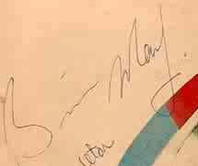  Brian's signature from 1978 - still looked like in the early years. | 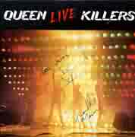  Signatures on a Live Killers LP, probably from 1979.

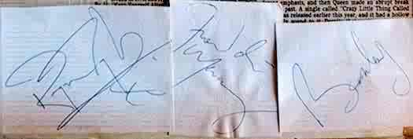
Freddie, Brian and Roger in 1978.
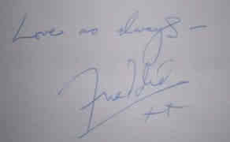  I THINK this signature is on a postcard that Freddie sent to David Minns on Xmas 1980. | 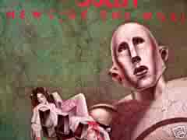  Something from a recent ebay auction. Signed in early 80's when the owner was on holiday in the UK.

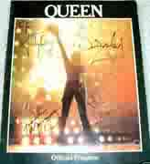  One of the few genuine signed items on eBay :-) | Freddie's signature from eil.com.

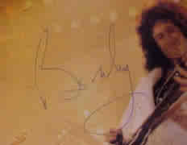  Brian's signature from The Game tour program. Very typical for that era. Four years before or four years later it would look different. | 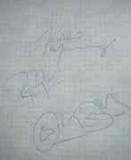  Obtained on 06.08.1980 before the concert at Riverside Controplex in Baton Rouge, USA by a girl called Sally.

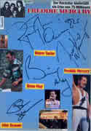  Queen signatures obtained in Germany during the Hot Space tour (the magazine cuttings were glued on later). Freddie's looks quite strange but the others three are genuine without any doubt. | 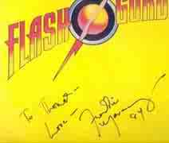  Very nice example of Freddie's typical handwriting. Obtained most likely during the Works tour in Germany. This is what most Freddie's signatures should look like!

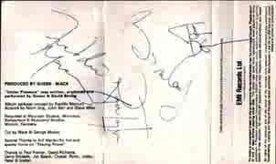  Beautiful signatures on a Hot Space casette. | 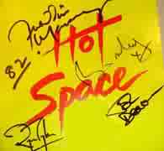  Freddie's is quick and ugly but the rest is beautiful.

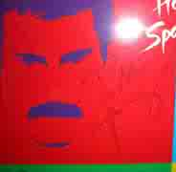  Hot Space era. | 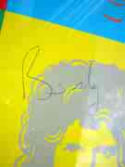  Hot Space era.

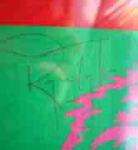  Hot Space era. | 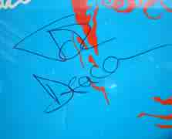  Hot Space era.

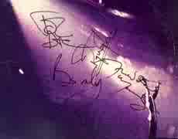  Signatures obtained after a Queen concert in Germany in 1982. | 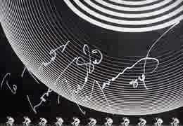  Typical Freddie's signature with a dedication. From the auction at a Dutch fan club meeting.

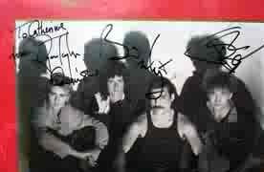  A beautiful set from 1984, pity that Freddie is missing. | 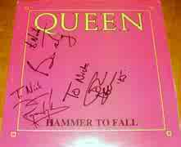  Almost the same example as the one from 1984 (see above) - strange that Freddie's autograph is missing again :-)

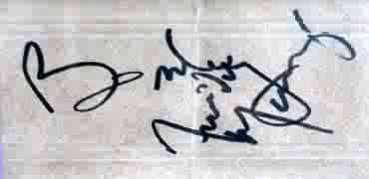
Obtained after the concert in Frankfurt (1984). Freddie's a bit quick on this one :-)

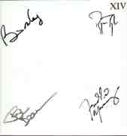  The famous limited edition of the 'Complete Works' box set signed by all members. Typical example of signatures of all four members. | 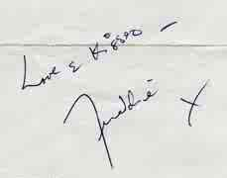  Freddie's signature on a piece of paper.

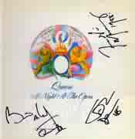  From Andy Young's collection (currently for sale for 500 UK pounds). | 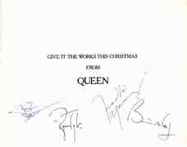  A 1987 Xmas card with genuine signatures.

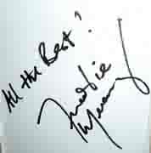  Freddie's signature from 1988 - from my friend's collection. | 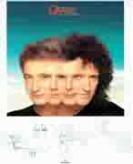  Preprinted signatures - you can have a look what Queen signatures looked like in late 80's (they're slightly different).

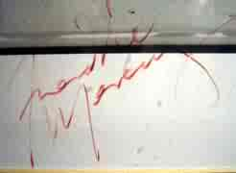  Freddie's signature on a Works promo poster, obtained 1989. | 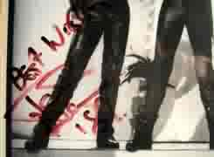  John's signature on a Works promo poster, obtained 1989.
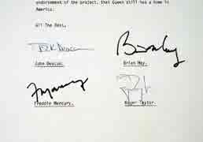  Innuendo award - there are quite a few of them on the market but they never sell for less than $1000. Note Freddie's weird signature - he used this only for official documents. | 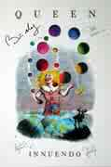  Signed Innuendo poster - one of Freddie's last signatures.

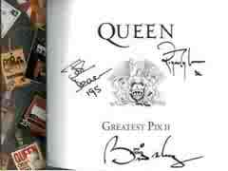  The 'Greatest Pix II' book signed by the three remaining members in 1995. Nice and clear signatures - they haven't changed since. | 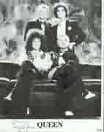  'I'm Going Slightly Mad' promo photo signed in 1994 and sold in the Convention auction.

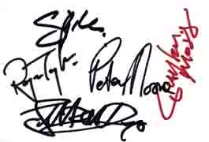  Signatures of The Cross (incl. Roger). | 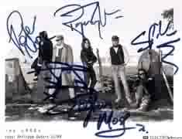  Signatures of The Cross (incl. Roger).

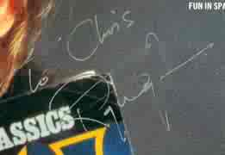  Typical Roger's signature. | 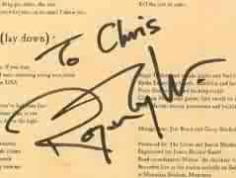  Typical Roger's signature.

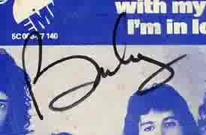  Brian's signature from 1993 | 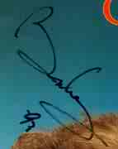  Brian's signature from 1993.

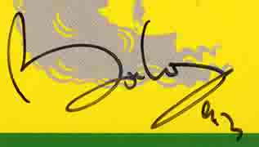  Brian's signature from 1993. | 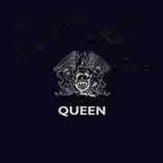  Ultrarare Virgin promo single from the 1997 competition on the Virgin radio. Signed by the three remaining members.

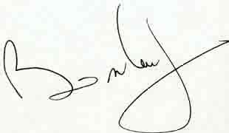  Brian's signature, probably from the 90's. | 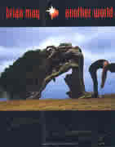  And finally something from the recent years - as you can see, Brian's signature has changed only very slightly since early 90's.

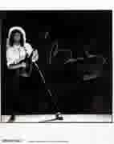  Brian's promo photo with his signature. Brian's signature can be recognized very easily (notice "B", "M" and "y") but it's not easy to fake it. | 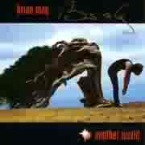  Another Brian's signature from 1998.

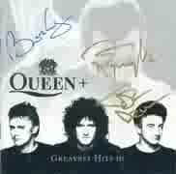  One of the last official items signed by all three remaining Queen members. | 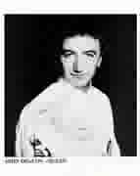  Somebody managed to meet John in 2005 - lucky him!

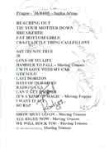
Something from the 2005 tour - Queen + Paul Rodgers (the whole band).

